**THE USE OF ECO-FRIENDLY COLLECTORS FOR FELDSPAR FLOTATION**

M. Olgaç KANGAL*, Gülay BULUT, Fırat BURAT, Onur GÜVEN, Zeynep TARSUS

*Istanbul Technical University, Faculty of Mines, Mineral Processing Engineering Department, 34469, Maslak, Istanbul, TÜRKİYE*

*\*Corresponding author: kangal@itu.edu.tr*

**A B S T R A C T**

The general circuit for purification of feldspar consists of three stages of flotation in very acidic medium. After desliming, in the first flotation stage, mica is removed with an amine collector. In the second stage, titanium and iron oxide minerals are removed using an anionic collector. In the third stage, feldspar is activated with fluoride ions using HF and floated with an amine. The sinking product is high grade quartz.

This study investigates the efficiency of eco-friendly fatty acid type of collectors working at alkali medium and Duomeen TDO compared with conventional feldspar flotation including the use of HF. The feldspar sample from Muğla-Turkey was subjected to Slon Magnetic Separator before flotation tests. The effects of reagents type and the amount of cleaning stage were investigated. The conventional three stage flotation using HF, flotation with an oxalic acid type collector (DERNA7 which floats mica and metal oxides in the same stage at alkali pH) and flotation with Duomeen TDO for quartz-feldspar separation (without HF) were compared in terms of product grade and flotation recovery.

The latest results are a feldspar concentrate with 11,15 % alkali (Na2O+CaO) grade for the conventional flotation using HF, a feldspar concentrate with 11,57% (Na2O+CaO) grade for the flotation with Duomeen TDO with similar recoveries. The alkali grade of oxalic acid type collectors flotation remained lower compared to others. The eco-friendly Duomeen TDO collector proved to be an efficient collector for feldspar flotation eliminating the use of HF.

***Key words:*** *Feldspar, quartz, flotation, eco-friendly collector*

**1. INTRODUCTION**

Most of the feldspar minerals are used in glass and ceramics industry. Feldspars are also used in plastics, paint and welding electrodes. The ratio of K2O/Na2O and the presence of metal oxide impurities makes the quality of feldspar. The only enrichment method for feldspars is flotation with or without magnetic separation. The general circuit for purification of feldspar consists of three stages of flotation in very acidic medium. After desliming, in the first flotation stage, mica is removed with an amine collector. In the second stage, titanium and iron oxide minerals are removed using an anionic collector. In the third stage, feldspar is activated with fluoride ions using HF and floated with an amine to separate feldspar from remaining quartz (Bayraktar et al., 1997, Çelik et al., 1998, Demir et al., 2003).

The separation of feldspars from quartz by flotation applying the conventional HF-method is no longer acceptable from an environmental and health point of view. Moreover, new ceramic composite materials require high quality components for their industrial scale production. Therefore, the search for a new reagent for selective separation is under serious consideration. Previous studies have mainly concentrated on the separation mechanism of quartz and feldspar (Sekulić et al., 2004, Salmawy et al., 1993, Orhan and Bayraktar, 2006)

A number of studies were conducted in which feldspar was floated without use of HF. The process described the uses of a mixture of cationic and anionic collectors in an acid circuit of about pH 2 without use of HF. Alkyltrimethylene diamine acetate together with sodium petroleum sulfonate are used as a collector, and acid pH is concentrated with either sulfuric or hydrochloric acid. Another collector suitable for feldspar flotation without the use of HF is Duomeen TD6 (N-tallow 1, 3 propylene diamine dioleate) with carboxylate anionic group instead of sulfonate gave good separation results (Bulatovic, 2015, Liu and Gong, 1985).

**2. MATERIAL AND METHODS**

**2.1. Material**

A representative sample was obtained from Muğla-Milas region. According to screen analysis results 3,5% of the sample is +0,300 mm and 5,5% of the sample is -0.063 mm (Figure 1). According to the particle size distribution curve, d80 particle size was determined as 0,210 mm.

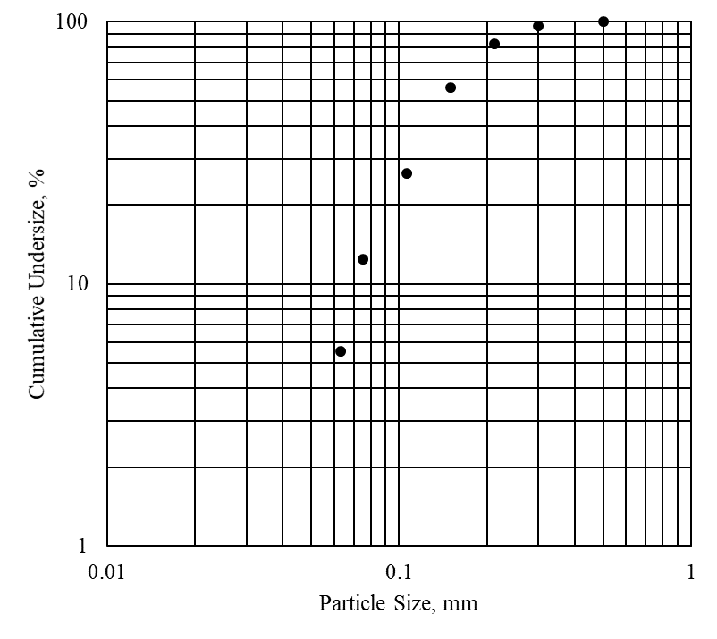

Figure 1. Particle size distribution of representative ore sample

**2.2. Method**

After magnetic separation and desliming by 63 microns, the chemical composition of the sample was of 0,36% K2O, 10,2% Na2O, 0,39% CaO, 0,13% TiO2, 0,16% Fe2O3, 17,2% Al2O3 and 69,6% SiO2 as determined by the XRF technique. Further purification was required by the company in order to improve economic value and quality of the final product.

Flotation experiments were carried out in a laboratory scale Denver D-12 model flotation machine with a cell capacity of 2.5 l. A sample of about 500 g was mixed with tap water making 20 % solid pulp ratio, at approximately 1500 rpm impeller speed at desired pH. Flotation studies were carried out at both alkali and acidic pH using NaOH and H2SO4. A conditioning period of 15 min for HF, 5 min for both collector and frother was allowed. MIBC was used as frother. Froth was collected for 2 minutes. For conventional feldspar flotation 300g/t DAHC (Dodecylamine hydrochloride), 1200+1200 g/t R801+R825 (sulphonate type of collectors), 1200g/t V4343 and 1000g/t HF were used. For alkali flotation using DERNA7 (fatty acid type of collector) 2400 g/t of collector was used. For the HF free flotation, 300g/t DAHC (Dodecylamine hydrochloride), 1200+1200 g/t R801+R825 (sulphonate type of collectors) and 1500g/t Duomeen TDO (tallowpropylene diamine dioleate) were used.

**3. RESULTS AND DISCUSSION**

This study investigates the efficiency of such collector, namely Duomeen TDO. The feldspar sample from Muğla-Turkey was subjected to Slon Magnetic Separator before flotation tests. The effects of reagents type and the amount of cleaning stage were investigated. 1)The conventional three stage flotation, 2) flotation with an oxalic acid type collector (DERNA7) floating mica and metal oxides in the same stage at alkali pH and 3) flotation with Duomeen TDO for quartz-feldspar separation (no HF was used at this stage) were compared in terms of product grade and flotation recovery. The conditions are shown in Table 1.

Table 1. Flotation conditions for 3 types of collector

|  |  |
| --- | --- |
| **Collector type** | **Flotation conditions** |
| Conventional feldspar flotation using HF | Mica stage (DAHC) pH:2.5  Oxide stage(R801+R825) pH:3.5  Feldspar stage **(V4343+HF)** pH:2.5 |
| Fatty acid type collector | Mica+oxide stage **(DERNA 7)** pH:9.5 |
| Diamine type collector replacing HF | Mica stage (DAHC) pH:2.5  Feldspar stage **(Duomeen TDO)** pH:2 |

In Figure 2, flowsheet for conventional feldspar flotation and flowsheet for DERNA7 Flotation including mica+oxide stage only is given in Figure 3. The products grades and recovery values are given in Table 2.



Figure 2. Flowsheet for conventional feldspar flotation



Figure 3. Flowsheet for DERNA7 Flotation including mica+oxide stage only

In Figure 4, flowsheet for Duomeen TDO Flotation including mica and 2 stages of feldspar flotation is shown. In these experiments Duomeen TDO (tallowpropylene diamine dioleate) as a cationic was used at pH 2. The results were successful compared with conventional feldspar flotation. The results are given in Table 2.



Figure 4. Flowsheet for Duomeen TDO Flotation including mica and 2 stages of feldspar flotation

**4. CONCLUSION**

The latest results are a feldspar concentrate with 11,15 % alkali (Na2O+CaO) grade for the conventional flotation using HF, a feldspar concentrate with 11,57% (Na2O+CaO) grade for the flotation with Duomeen TDO with similar recoveries. The alkali grade of oxalic acid type collectors flotation remained lower compared to others. The eco-friendly Duomeen TDO collector proved to be an efficient collector for feldspar flotation eliminating the use of HF.

Table 2. Flotation test results

|  |  |  |  |  |  |  |  |  |  |  |  |  |  |  |  |  |  |  |
| --- | --- | --- | --- | --- | --- | --- | --- | --- | --- | --- | --- | --- | --- | --- | --- | --- | --- | --- |
| Collector Type | Product | Weight, % | Fe2O3, % | | TiO2, % | | SiO2, % | | | Al2O3, % | | | Na2O, % | | | CaO, % | | |
| Content | Recovery | Content | Recovery | Content | Recovery | Content | | Recovery | Content | | Recovery | Content | | Recovery |
| DAHC  R801-825  V-4343+HF | Feldspar Concentrate | 74,2 | 0,03 | 12,4 | 0,03 | 19,4 | 70,05 | 73,0 | 18,82 | | 78,5 | 11,19 | | 82,0 | 0,35 | | 66,0 |
| Feldspar Middlings | 9,6 | 0,05 | 3,1 | 0,08 | 5,9 | 69,59 | 9,4 | 18,70 | | 10,0 | 11,13 | | 10,5 | 0,35 | | 8,5 |
| Quartz Concentrate | 6,8 | 0,02 | 0,8 | 0,03 | 1,8 | 94,37 | 9,0 | 4,62 | | 1,8 | 0,01 | | 0,1 | 0,05 | | 0,9 |
| Oxide Concentrate | 6,5 | 0,23 | 9,3 | 0,73 | 38,7 | 68,32 | 6,3 | 18,24 | | 6,7 | 10,64 | | 6,9 | 0,51 | | 8,5 |
| Mica Concentrate | 2,9 | 4,15 | 74,4 | 1,44 | 34,2 | 56,54 | 2,3 | 18,47 | | 3,0 | 2,21 | | 0,5 | 2,19 | | 16,1 |
| Total | 100,0 | 0,16 | 100,0 | 0,12 | 100,0 | 71,16 | 100,0 | 17,79 | | 100,0 | 10,13 | | 100,0 | 0,39 | | 100,0 |
| DERNA7 | Feldspar Concentrate | 87,3 | 0,05 | 27,0 | 0,05 | 35,5 | 70,33 | 87,3 | 17,42 | | 87,8 | 10,81 | | 90,5 | 0,33 | | 70,3 |
| Mica+Oxide Concentrate | 12,7 | 0,87 | 73,0 | 0,59 | 64,5 | 70,54 | 12,7 | 16,58 | | 12,2 | 7,80 | | 9,5 | 0,96 | | 29,7 |
| Total | 100,0 | 0,15 | 100,0 | 0,12 | 100,0 | 70,36 | 100,0 | 17,31 | | 100,0 | 10,43 | | 100,0 | 0,41 | | 100,0 |
| DAHC-Duomeen | Feldspar Concentrate | 77,8 | 0,04 | 18,4 | 0,10 | 60,5 | 69,25 | 77,4 | 18,02 | | 81,5 | 11,21 | | 85,0 | 0,36 | | 71,1 |
| Feldspar Middlings | 9,9 | 0,04 | 2,4 | 0,07 | 5,5 | 73,48 | 10,4 | 15,83 | | 9,1 | 9,10 | | 8,8 | 0,31 | | 7,8 |
| Quartz Concentrate | 7,2 | 0,02 | 1,0 | 0,03 | 1,7 | 74,13 | 7,6 | 9,50 | | 4,0 | 5,19 | | 3,6 | 0,16 | | 2,9 |
| Mica Concentrate | 5,1 | 2,46 | 78,2 | 0,80 | 32,3 | 61,94 | 4,6 | 18,27 | | 5,4 | 5,18 | | 2,6 | 1,40 | | 18,2 |
| Total | 100,0 | 0,16 | 100,0 | 0,13 | 100,0 | 69,61 | 100,0 | 17,20 | | 100,0 | 10,26 | | 100,0 | 0,39 | | 100,0 |

**REFERENCES**

Bayraktar, İ., Ersayin, S., Gülsoy Ö. Y., (1997) “Upgrading titanium bearing Na-feldspar by flotation using sulphonates, succinamate and soaps of vegetable oils”, Minerals Engineering, 10 (12) 1363-1374.

Bulatovic, S. M., (2015), Chapter 32-Beneficiation of Feldspar Ore, Handbook of Flotation Reagents: Chemistry, Theory and Practice, 107-119.

Çelik, M. S., Can, S. I., Eren, R. H.,(1998) “Removal of titanium impurities from feldspar ores by new flotation collectors”, Minerals Engineering, 11 (12) 1201-1208.

Demir, C., Bentli, I., Gülgönül. I., Çelik, M. S., (2003) “Effects of bivalent salts on the flotation separation of Na-feldspar from K-feldspar”, Minerals Engineering, 16 (6) 551-554.

Liu, Y., Gong, Y., (1985), “A new flotation technique for feldspar quartz separation”, XXIII International Mineral Processing Congress Publication, 4, 857–862.

Orhan, E. C., Bayraktar, İ., (2006) “Amine–oleate interactions in feldspar flotation”, Minerals Engineering, 19 (1) 48-55.

Salmawy, M. S., El-Nakahiro, Y., Wakamatsu T., (1993) “The role of alkaline earth cations in flotation separation of quartz from feldspar”, Minerals Engineering, 6 (12) 1231-1243.

Sekulić, Ž., Canić, N., Bartulović, Z., Daković, A., (2004) “Application of different collectors in the flotation concentration of feldspar, mica and quartz sand”, Minerals Engineering, 17 (1) 77-80.